Kentucky Space Grant Consortium

Aerospace Workforce Faculty Researchers Graduate Students Undergraduates Teachers for the STEM Pipeline
Public Education

Plan for 2009
Interim Director: Dr. Michael Carini
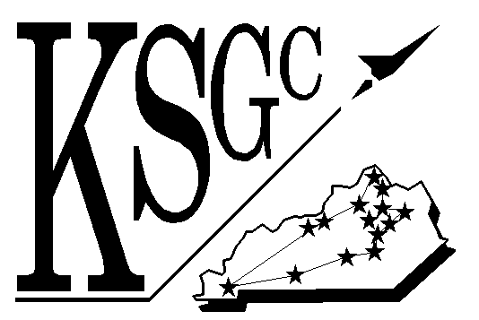

Western Kentucky University
Department of Physics and Astronomy
1906 College Heights Blvd. #11077
Bowling Green, KY 42101-1077
Phone: 270-745-4156/6198
FAX: 270-745-4156/2014
Email: nasa@wku.edu
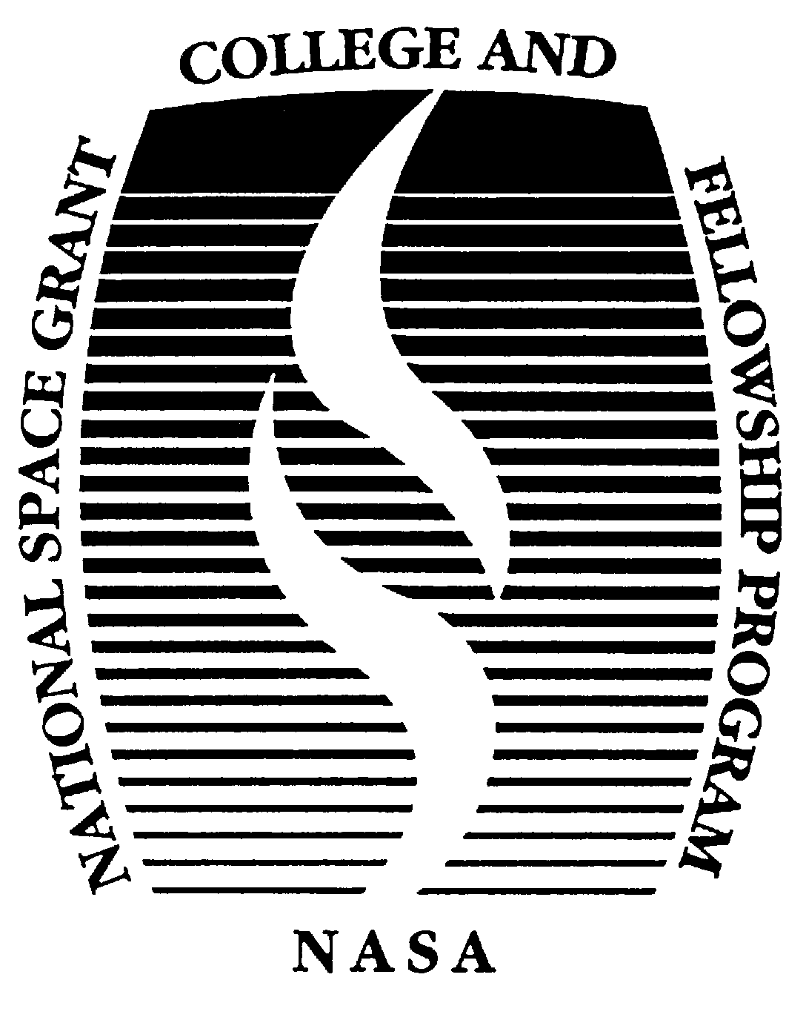

Michael Carini
May 2009

Western Kentucky University Research Foundation

Kentucky Space Grant Consortium

Plan for 2009

Certification of Compliance with Applicable Executive Orders and U.S. Code

By signing and submitting the proposal identified in this Cover Sheet/Proposal Summary in response to the NASA request for a proposal under the National Space Grant College and Fellowship Program, the Authorizing Official of the proposing institution, as identified below:

1. certifies that the statements made in this proposal are true and complete to the best of his/her knowledge;

2. agrees to accept the obligations to comply with NASA award terms and conditions if an award is made as a result of this proposal;

3. provides certification to the following that have been reviewed on the following
NASA website http://code210.gsfc.nasa.gov/grants/grants.htm#Grant_Forms):
(i) Certification for Debarment, Suspension, and other Responsibility Matters;
(ii) Certification Regarding Lobbying; (iii) Assurance for Nondiscrimination Compliance.

Institution Authorization:

Marilyn Anderson
Operations Manager, WKURF
Western Kentucky University

KSGC Plan for 2009

The Kentucky Space Grant Consortium has been established as a major avenue for connecting Kentucky's students, faculty, teachers, and general public to NASA's scientific exploration of the universe. KSGC supports a broadband spectrum of activities that involve learners at all levels in the excitement of NASA's journey. The program is designed to meet NASA's needs in The Vision for Space Exploration and the needs of Kentucky.

KSGC recognizes that the students in schools and colleges today will provide much of the workforce who will contribute to NASA's realization of the Vision for Space Exploration. They are the next generation of explorers, whom NASA and KSGC seek to inspire. The inspiration of these students and their preparation for the needed workforce are the central mission of the Kentucky Space Grant Consortium.

KSGC specifically addresses and supports the outcomes sought in the 2006 NASA Strategic Plan for
Education:

ED-1: Contribute to the development of the STEM workforce in disciplines needed to achieve
NASA’s strategic goals through a portfolio of investments

ED-2: Attract and retain students in STEM disciplines through a progression of educational opportunities for students, teachers, and faculty.

ED-3: Build strategic partnerships and linkages between STEM formal and informal education providers that promote STEM literacy and awareness of NASA’s mission.

Needs of Kentucky: The KSGC Program is designed to serve identified needs of the Commonwealth of Kentucky within the framework of national emphases for Space Grant programs. Relevance of KSGC to the needs of Kentucky is indicated by the following basic facts:
Kentucky in 2003 ranked 39th in NASA funding and 40th in federal R&D funding Kentucky in 2004 ranked 48th in percentage of scientists/engineers in the workforce Kentucky in 2005 ranked 47th in educational attainment of the workforce
Kentucky began in 1990 a process of thoroughly revising its system of public education

Kentucky has a population of 4.0 million (2000 U.S. census), of which 7.7% are African American, 0.9% are Asian, 0.6% are Native American, and 0.9% are other races (totaling 10.1% minority population). The Hispanic and Latino population of all races is 1.5%. The urban population increased from 52% in 1990 to 56% in 2000. Kentucky's economy was traditionally based largely on agriculture and mining; however, manufacturing and service industries now lead the economy. Kentucky's major industries include Ford, Toyota, and GM/Corvette manufacturing plants, Lexmark, GTE, GE, and a major UPS air hub. Kentucky has neither a NASA Center nor a significant aerospace industry presence. For enhancing its technology-based state economy, Kentucky can benefit from involving more of its faculty and students in space-related R&D, working toward future employment of graduates by NASA and aerospace industry.

Needs of Kentucky are addressed through the following KSGC objectives, by using the inspiration of aerospace- and NASA-related subjects and activities to achieve:
- Enhancement of research and education capabilities in space-related fields
- Increased numbers of people training for the workforce in space-related fields
- Greater public exposure to NASA and space-related research and applications

Membership: The fourteen affiliate members of KSGC, distributed throughout Kentucky, are listed alphabetically and characterized below:

Kentucky Space Grant Consortium Network
Institution | Location | Description
Bellarmine University | Louisville | Private Comprehensive University
Centre College | Danville | Private Liberal Arts College
Eastern Kentucky University (EKU) | Richmond | Public Comprehensive University
Kentucky Science & Technology Corp | Lexington | Non-profit Organization
Kentucky State University | Frankfort | Public Comprehensive Univ./HBCU
Morehead State University | Morehead | Public Comprehensive University
Murray State University | Murray | Public Comprehensive University
Northern Kentucky University (NKU) | Highland Hgts. | Public Comprehensive University
Thomas More College | Crestview Hills | Private Liberal Arts College
Transylvania University | Lexington | Private Liberal Arts University
Tribo Flow Separations, LLC | Lexington | Industry
University of Kentucky (UK) | Lexington | Public Doctoral Granting University
University of Louisville (U of L) | Louisville | Public Doctoral Granting University
Western Kentucky University (WKU) | Bowling Green | Public Comprehensive University

Proposed Program Implementation

The KSGC program is designed to meet NASA's needs in The Vision for Space Exploration and the needs of Kentucky. Its implementation is shaped by the goals of the national Space Grant program and guided by the principles of NASA's Office of Education:
Feasibility: The proposed implementation of the KSGC is founded on a well-established base of operating principles and practices that work well in and for Kentucky. Through experience, KSGC has developed understanding of successful approaches that achieve the goals of all partners; and to that end the plan is to utilize even more of the National Space Grant and other providers’ support services.
Content: Our programs and projects are directly tied to or make use of NASA data, information, research content, activities, personnel, or facilities to involve higher education students and faculty in NASA-related science, technology, engineering, or mathematics (STEM).
Customer Focus: The KSGC Program responds at all levels to needs that have been identified by the education community and by NASA, as outlined in the "pipeline" discussion below. The inspirational power of aerospace/exploration activities motivates enhanced involvement and preparation of the education community of teachers and learners, while benefiting NASA in the development of a workforce that has been trained and inspired by involvement in the Vision.
Pipeline: Preparation for aerospace workforce development in our program includes:
(1) enhancing teachers' abilities to engage precollege students in "hands-on" learning experiences that inspire preparation for STEM areas in college, (2) attracting highly qualified college STEM students for involvement in NASA-related research and mission experiences, and (3) motivating retention to graduation and pursuing advanced studies through faculty mentoring in research and interdisciplinary team experiences.
Diversity: Our program works at all levels to attract and retain diverse participants, including women, members of underrepresented groups (which includes persons with disabilities) in preparation for NASA-related STEM careers, to promote and develop a diverse STEM workforce for the future. Our affiliate Kentucky State University is an HBCU.
Partnerships and Sustainability: Our program is a partnership of member institutions with a collaborative organizational structure that promotes competitively-based project development throughout the Consortium. We partner with other local organizations to sustain public involvement, with the Kentucky Department of Education to sustain education programs for state needs, and with NASA and industry on a national scale to sustain workforce development.

Strategic Implementation/Program Plan
KSGC member institutions of higher education and their programs provide fundamental support for strengthening the STEM education base in Kentucky and for the direction of the Agency through the following spectrum of strategic program elements:

Aerospace Workforce Development -- is KSGC's prime goal, supported by each of the following elements, and by interdisciplinary, team-based, mission-oriented projects and links with NASA (NASA ED-1, 2)

Faculty Researchers -- are resources at the highest level in the workforce, to provide enhanced emphasis on student research, NASA collaboration, and Center visits (ED-1, 2)

Graduate Fellowships -- support mentored research for graduate student development, with enhanced NASA collaboration for Fellowship projects and NASA Center visits (ED-1, 2)

Undergraduate Scholarships -- support mentored research for undergraduate students, with enhanced participation in NASA internship programs (ED-1, 2)

Teacher Training -- prepares teachers for inspiring students in the STEM pipeline, with enhanced NASA-based materials for use in classrooms, and with pre-service internships (ED-2)

Public Support -- is promoted through involvement for awareness of aerospace issues and
NASA, with enhanced support for leveraging informal education partnerships (ED-3)
The following sections of this plan provide details of how these program elements will be conducted to strengthen the education base in Kentucky and to support the direction of NASA. KSGC program

elements specifically address key national program emphases including competitiveness, research opportunities, diversity, student mentoring, and interdisciplinary education and research.

ED-1: Contribute to the development of the STEM workforce in disciplines needed to achieve
NASA’s strategic goals through a portfolio of investments

ED-2: Attract and retain students in STEM disciplines through a progression of educational opportunities for students, teachers, and faculty.

Fellowship/Scholarship Program

The KSGC Fellowship/Scholarship Program facilitates
research-based training of undergraduate and graduate students for the workforce in aerospace-related fields. The recipients generally advance through graduate studies and/or take employment in STEM areas. Many will eventually be employed either by NASA, by NASA contractors, or by universities as faculty members working in NASA-related research. Most come to the program motivated by an abiding interest in aerospace, NASA and NASA-related fundamental sciences.
Undergraduate research typically leads to the pursuit of advanced studies in the field

Objectives of our Fellowship/Scholarship Program are
.
- Increased numbers of people training for the workforce in space-related fields
- Effective preparation based upon research experiences for the students

Characteristics: Awards of Graduate Fellowships and Undergraduate Scholarships are competed statewide, and require a faculty-mentored student research project in an aerospace-related field or teaching area. Awards are based on student qualifications and on the research proposal. Students at all member institutions are eligible to submit proposals co-written with a faculty mentor. The KSGC Committee of all of the Campus Directors decides on awards.

Graduate Fellowship awards are in amounts up to $18,000 per year. Undergraduate Scholarship awards are up to $5,000 per year. Fellows and Scholars must be U.S. citizens and must be accepted for admission to a program at a Consortium institution leading to a degree in an aerospace-related field or teaching area. We encourage applications from women and other underrepresented groups, and from students in NASA projects such as NASA EPSCoR. Because of special needs for additional Fellowships/Scholarships to facilitate our next workforce development initiative, we are increasing the annual target for the 2009 Budget to 13 awards ($300,000).
KSGC Scholars and Fellows make public presentations of the results of their projects.
Recruitment of applicants for fellowships and scholarships is naturally vested in the faculty mentors who are willing to commit to the effort of mentoring a year-long student research project. The potential faculty mentor is in the best position to know the local pool of potential student researchers and to judge those who are likely to maintain interest and succeed in a project in the mentor's field of expertise. Each fellowship or scholarship is awarded to a particular student, based on that student's academic credentials and the mutual commitment between the student and mentor in their proposed research project. Retention is achieved through the positive effects of research experience and success on the student's motivation to continue to graduation in preparation for a research-based career.
Diversity: KSGC strongly encourages the inclusive participation of women and members of underrepresented groups, including persons with disabilities. Our faculty mentors are supportive of this goal as they seek students to propose for fellowships and scholarships for projects under their mentorship. Their success in achieving this goal is highly dependent on the pool of students enrolled in their discipline. In STEM areas, populations of women and members of underrepresented groups are typically well below the population percentages of each in the overall university population (mostly non-STEM disciplines) and of the state (see Table below). This situation is one reason for the term "underrepresented", and the roots of the problem are in the earlier pipeline of too few students who focus on STEM directions early enough to be prepared to pursue them in college. The program “Student Training and Achievement in Research (STAR)” was designed primarily to encourage underrepresented minorities to participate in research and to present their results. Awards are made to students based upon demonstrated research interest, potential, and participation. Students are recruited by mentors who will mentor them throughout their studies at the consortium institution.

Kentucky Population Statistics, and
Women and Minorities Prepared for STEM Participation in Higher Education
Population Data from 2000 Census, Enrollments/Degrees 2001 | Women | Minorities
Kentucky’s General Population | 51% | 10.1%
Kentucky’s University Population (All Disciplines) | 58.6% | 9.4%
*Eligible University of Kentucky STEM-Enrolled Pool (#Degrees) | *30.5% | *2.6%
*These are the most optimistic indicators, based on the largest and most attractive programs in the state.

Although fellowship and scholarship resources applied at the higher-education level cannot significantly increase the available STEM population at that point, they can be very effectively applied within this population to help retain capable students to the point of graduating and pursuing advanced STEM studies. They can also steer some of the STEM population specifically toward NASA-related career tracks.

The numbers in the table reflect the realistic situation in the most optimistic fashion by using the best case of the University of Kentucky enrollment statistics as our target basis. If we are fortunate enough, through the research-recruiting efforts of the mentors, to have eligible
KSGC Scholar and KC-135 team member who went on to NASA Academy at Goddard.

minority students apply in larger numbers; we will make a special effort to make awards to them.

Metrics, Targets, and Effects: The metrics to be used to evaluate the success of the Fellowship/Scholarship program derive directly from the objectives of (1) increased numbers of people training for the workforce in space-related fields and (2) effective preparation based upon research experiences for the students. The quantifiable metrics and annual targets are given below. Our competitively selected, mentored-research-based Fellowships and Scholarships will contribute to the support of NASA's direction through enhanced development of aerospace workforce with degrees in higher education and experience in research. As shown in our progress report, we achieved or exceed the target metrics from last year.

Fellowship/Scholarship Metrics | Annual Target
Number of research-based Fellowship/Scholarship awards | 13
Percent retained to graduation | 95%
Percent of graduates entering advanced studies or STEM employment | 90%

Research Infrastructure Program

Purpose and Goal: The purpose and goal of our Research Infrastructure Program is for faculty to provide research experiences for students, thus developing and increasing capabilities of Kentucky researchers at all levels in contributing to the aerospace workforce.
Objectives of our Research Infrastructure Program are:
To use our research infrastructure to enhance the
aerospace workforce in Kentucky, through:
Interdisciplinary research is fostered by collaborations with NASA, such as KSGC projects in inflatable structures with Langley
.
- Increased numbers of Kentucky student and faculty
aerospace-related researchers
- Connection of Kentucky research efforts to NASA interests and researchers
- Enhanced competitiveness of Kentucky researchers for NASA and other funding
The aerospace workforce consists of employees of NASA, employees of NASA contractors,
employees of aerospace industries, and university faculty engaged in aerospace and NASA
research. Our Research Infrastructure Program develops research capabilities and connections with
NASA, and is especially important as a platform for involving students in research as a basis for their
development as members of the aerospace workforce in any of the listed roles.
Diversity: Student participants in the research projects are recruited by the faculty who are
willing to mentor students as part of their research. Proposers are instructed that additional scoring points
will be given in the reviews for the recruitment and involvement of women and members of
underrepresented minorities, including persons with disabilities in, research experiences. Since
our awards are competitively based, they provide both motivation and mechanism for recruitment
of targeted populations on-site, where the research opportunities exist and can directly attract
participation. Our targets are the available STEM populations of 30.5% women and 2.6%
underrepresented groups.

Collaboration with NASA ensures an interdisciplinary dimension. NASA's projects and interests are generally interdisciplinary -- there is a problem to be solved or a mission component to be developed. By engaging in a project of interest to NASA, and working with a NASA collaborator, the researcher participates in an interdisciplinary effort and gains an interdisciplinary perspective and appreciation that might never have been acquired otherwise.

KSGC invites proposals for amounts up to $15,000 in "seed" funding to initiate aerospace-related research projects by faculty at member institutions. Faculty are required to include student research participants in their projects and budgets, and to take their students to visit the NASA Center and personnel relating to the project. This "seed funding" should enable the faculty and student(s) to establish NASA- or aerospace-related research. In some cases it is a unique avenue for faculty at non- doctoral, comprehensive universities and private colleges to initiate research that establishes future opportunities for themselves and students at these institutions. The project is also intended to enhance the investigator’s competitiveness for future funding. Eligibility for renewal is contingent upon quantifiable performance metrics including publications, presentations, and follow-on proposals to NASA or other agencies. Decisions on the awards are made by the KSGC Committee.
KSGC research projects in NASA's reduced- gravity facilities are a major attraction for student researchers. The student with the banner went on to Harvard Medical School.

Metrics, Targets, and Effects: The quantitative metrics and annual targets by which we evaluate success of the Research Infrastructure Program are given below. Meeting the objectives will serve to develop enhanced research infrastructure at all levels in higher education in Kentucky, contributing to the development of aerospace workforce that supports the direction of NASA and enables its future.

Research Infrastructure Metrics | Annual Target
Number of faculty and students supported | 10
Number of collaborations with NASA | 5
Competitiveness of researchers | Overall RI program follow-on 2x investment
Number of publications and/or presentations | Average at least 1 per project

KSGC Education Programs
Overview of Purpose and Organization of Program: The KSGC Education Program is designed to provide support for improvement of the STEM education base in Kentucky. At the earliest level in developing the STEM pipeline, our Precollege Program emphasizes improvement of teachers' capabilities to implement content standards in ways that inspire more precollege students to pursue preparation for STEM careers. Our Higher Education Program emphasizes involvement of college students in interdisciplinary, team-based workforce development projects, relating to NASA and the workforce that will support its future. We will describe how the implementation of each activity supports the direction of NASA, by:

- Using elements of NASA's direction as motivational features in our activities
- Preparing members of the aerospace workforce to support NASA's direction

ED-2: Attract and retain students in STEM disciplines through a progression of educational opportunities for students, teachers, and faculty.

1. KSGC Precollege Program

Purpose and Goal: The purpose and goal of our Precollege Program is to enhance teachers' abilities to provide hands-on learning activities that present standards-based content in ways that inspire students' interest in STEM subjects and careers.
Objectives of our Precollege Program are: Increased numbers of in-service teachers prepared for hands-on STEM teaching with NASA-based subjects and materials

Increased numbers of pre-service teachers prepared for hands-on STEM teaching with NASA-based subjects and materials
Teachers testing the telescopes they built as part of a KSGC workshop, to use with their students to (safely) observe the sun, moon, and planets.

Workshops for In-Service and Pre-Service Teachers: The principal application of precollege funding resources will be for conducting teacher workshops in STEM fields to enhance in- service teachers' preparedness for teaching their subjects in exciting ways that directly involve students in activities and inspire greater interest in STEM subjects. This purpose fulfills a need of Kentucky identified in the Kentucky Education Reform Act of 1990. That act mandated student-involvement-based teaching, but did not provide means of "re-training" teachers who had traditionally taught with very little hands-on involvement

A teacher examines NASA lunar samples in a KSGC workshop
activity. Beginning with its founding in 1992, KSGC worked to help fill this need of the systemic education reformation in Kentucky, in cooperation with the Eisenhower Math and Science Program in Kentucky. When that program changed, KSGC experienced a rise in the number and scope of workshop proposals, which presented an opportunity for KSGC to train more teachers based on aerospace and NASA concepts. Training teachers is vital to the development of the STEM pipeline in Kentucky.
Workshop funding will be competitively awarded to faculty at member institutions based on proposals meeting specific needs of the state. Workshop participants will evaluate workshop delivery, relevance of the material to their teaching needs in regard to state standards, and applicability of the techniques in their classes. Follow-on evaluations will identify what works best to meet actual needs. The workshops each typically serve about 10 teachers with individual attention in learning to use

the materials in their classes. With 7 NASA Explorer Schools (3 elementary, 3 middle, and 1 high school) in the state, we are inviting the Explorer School teachers to participate in workshop offerings that address state standards and specific needs in achieving NASA's goals in their schools.
Dr. Neil Tyson (upper right), who later served on the President's Aldridge Commission, helps conduct a KSGC minority workshop at Western Ky. U.

With a budget of $40,000, we will be able to support at least two teacher workshops per year at up to $10,000 each, and other KERA-College Interface curriculum development projects.
Support of State and National STEM Standards: During the development of systemic reform of precollege education in Kentucky in the 1990s, Karen Hackney, then KSGC's Associate Director, was instrumental in developing Kentucky's science education standards in earth and space sciences at all levels, including extending them through high school. The standards were derived from the National Science Education Standards. Kentucky teachers are especially interested in methods of teaching that will help them achieve these standards, which are fundamental to the student performance that is part of the evaluation of Kentucky's teachers and schools. Proposals for teacher workshops must address how the workshop will support the standards and how NASA-based topics and materials will be used to achieve the goals. NASA's Aerospace Education Specialists Program (AESP) reviews Kentucky's standards and selects NASA resources to support them. Some workshops include certification of teachers for borrowing lunar samples for their classes -- for the new generation who will be a part of NASA's return to the moon and preparation for Mars.

Support for Diversity: We encourage developers of workshops to appeal to and encourage participation of underrepresented groups, including persons with disabilities, in their workshops, and we give priority to those who can demonstrate ability to recruit diverse participation. In addition, some workshops involve expertise of college of education personnel in teaching how to recognize and to ameliorate gender-based obstacles to the inspiration and involvement of all students.
Partner Leveraging: KSGC and partner organizations on the campuses provide a wide range of supporting opportunities for precollege STEM interest and development. We distribute information about NASA opportunities, and KSGC Campus Directors encourage participation at their schools. KSGC provides information to help with viewing the ISS and listening to radio contacts between the astronauts and schools. Planetaria reach thousands of precollege students and their teachers each year with information from NASA's missions. Astronomy Club partners are implementing the NASA Night Sky Network and the NASA After School Astronomy Program. The NASA ERC at Murray State University provides NASA educational materials for teachers throughout the state, and the KSGC website (http://www.wku.edu/ksgc/) links to NASA CORE education materials. KSGC has plans to extend its partnership and support of the FIRST Lego Robotics program for Kentucky teachers to learn by doing with their student projects in robotics for K-12 students. In addition, the highly successful UTeach program, which is revolutionizing the preparation of pre-service STEM teachers, has been replicated at Western Kentucky University as SKYTeach. KSGC plans to investigate partner opportunities with SKYTeach during 2009.
Metrics, Targets, and Effects: The quantitative metrics and annual targets by which we evaluate success of the Precollege Education Program are given below. Meeting the objectives will increase the capabilities and capacity of Kentucky teachers in ways that inspire students toward career aspirations in STEM fields. NASA's direction is supported by using NASA missions and resources as bases for inspiration, role models, and content delivery.

Precollege Metrics | Annual Target
Numbers of workshops awarded | 2
Number of teachers intensively trained | 20

ED-1: Contribute to the development of the STEM workforce in disciplines needed to achieve
NASA’s strategic goals through a portfolio of investments

ED-2: Attract and retain students in STEM disciplines through a progression of educational opportunities for students, teachers, and faculty.
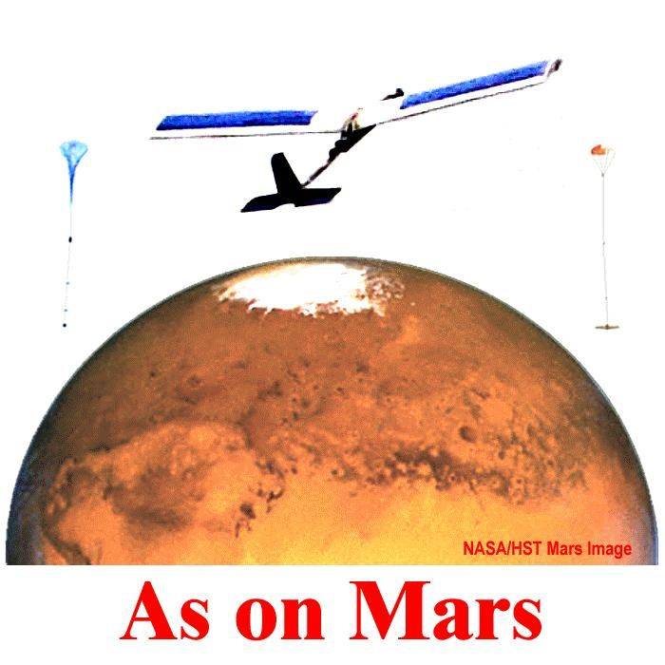

2. KSGC Higher Education Program Purpose and Goal:
Higher Education is the ultimate arena for refining career directions and developing students' fullest abilities to become part of the aerospace workforce of the future. In addition to our mentored research opportunities for individual students in Fellowship, Scholarship, and Research Infrastructure projects, we provide targeted higher education workforce development projects that involve teams of students in projects beyond the traditional disciplinary bounds of the curriculum and of individual-based research.
Objectives of our Higher Education Program are:
- Increased numbers of students training for the STEM workforce
- Development of student experience with interdisciplinary, team-based, mission-oriented aerospace projects supporting the direction of NASA
Program Characteristics -- Teamed Student Involvement in Interdisciplinary Mission-Oriented Experiences: Mission-based student team experiences are the crowning achievement and centerpiece of our program's contribution to aerospace workforce development (WFD). The missions are goal driven, requiring integration of interdisciplinary expertise, learning to work in teams to achieve shared goals, coordinating among teams to achieve the highest level project goals, and incorporating NASA resources, expertise, and inspiration to reach the goals. The projects emulate NASA missions, with students working in teams to define mission objectives, design and construct mission hardware, solve problems along the way, "fly" or otherwise execute the mission, interpret data from the mission, and present their results. All support NASA's direction in the Vision for Space Exploration.
Diversity: Faculty who recruit student participation in WFD projects seek the widest possible participation by women and members of other groups, including persons with disabilities. All offerings are equal-opportunity and are open to all students who are interested in participating in the team-based mission. Our targets are the available STEM populations of 30.5% women and 2.6% underrepresented groups.
Student Payload-to-Altitude Comprehensive Experiences ("SPACE" Missions): More than 250 students (mostly undergraduate, some graduate students) have worked with several faculty members at the University of Kentucky in developing and conducting five missions of BIG BLUE -- the Baseline Inflatable-wing Glider -- Balloon Launched Unmanned Experiment. The students work with ILC Dover, Inc., and NASA resources to design, build, and fly hardware to demonstrate the concept of inflatable fabric wings that can be compactly stowed, inflated, and used to fly exploration missions in the rarefied atmosphere of Mars. The missions use helium-filled balloons to carry the complex payloads to the "edge of space" -- altitudes near 100,000 ft in the earth's atmosphere, which simulate Mars' atmospheric density. The missions directly support NASA's Vision of robotic exploration of Mars. The students visit NASA Centers and are advised by engineers and researchers in NASA and aerospace industries.
Kentucky Student CubeSat Satellite Project: This project arose out of Kentucky's interaction with NASA Ames Research Center and opportunities developed with the Stanford Space Systems Development Laboratory (SSDL). Kentucky Space (nee KentuckySat (KySat)) is a joint-enterprise involving public organizations, colleges and universities and private companies in a student led initiative involving the design, build, launch, and on-orbit operation of small satellites. Kentucky Space trains and supports students in the dynamics of spacecraft design, development (including payloads), testing, launch and on-orbit operation of small satellites as a means of extending science and technology education, R&D, innovation and economic development in Kentucky.

The Mission Support Team works on a range of critical activities across multiple missions and project areas. These include but are not limited to spacecraft development, pre-flight testing embedded systems payload design, talent development, space physics, engineering, public communications, commercial applications computer programming, mechanical systems on-orbit operations, and marketing. Kentucky Space is an ongoing continuum of satellite design, build and launch projects, each with increasing scope and complexity, With the successful progress of the KySat 1 and 2 mission teams, a KySAT 3 team is being selected.

A suborbital launch took place December 5, 2007 involving eleven students. The launch was provided by Lunar Rocket and Rover Inc, and occurred at White Sands Missile Range in New Mexico. Due to unfortunate circumstances the launch vehicle did not attain the desired altitude; however the student payload performed flawlessly well past the maximum G-load and heat conditions.

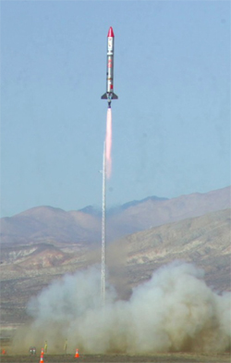
A second suborbital launch (see picture to the right) took place October 11, 2008, with a payload built by students in the Kentucky Space program. The flight test, designated Prospector 12A (P-12A), was a test flight conducted to verify liquid fueled propulsion technologies being developed by Garvey Spacecraft Corporation (GSC) in partnership with California State University, Long Beach (CSULB). The 1.7 pound student payload was designed to precisely measure details of the trajectory of the rocket in flight. The payload was successfully recovered and data analysis of the flight data has begun. Students in the Kentucky Space Consortium worked with engineers from GSC and students and faculty from CSULB and Stanford University on this project.

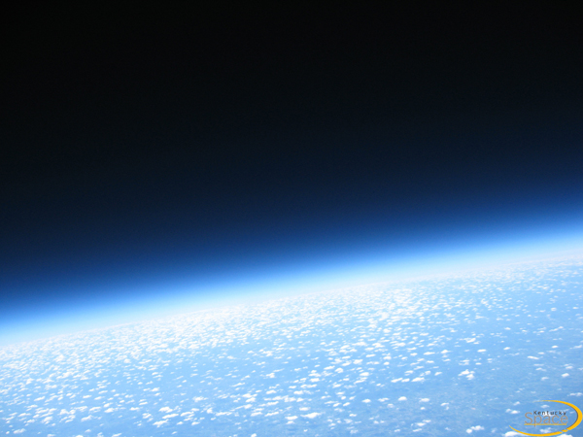
Kentucky Space along with KSGC sponsored a high altitude Balloon launch on July 14, 2008. The launch was in memory of Richard Hackney, the late director of KSGC. The student designed payload on Balloon 1 was a magnetometer and an inertial measurement unit. These instruments recorded valuable data at the edge of space for attitude control and determination and will aid in the design of future Kentucky Space orbital satellites. In addition, the mission will carried an experimental communication package to be tested for possible use in the event of a major natural or related disaster in Kentucky, and instruments and sensors that will be used in conjunction with other experiments in future flights to study regional climate change. Cameras videoed the flight, viewing the bluegrass state from the edge of space (see the picture above). Kentucky Space worked with the High Altitude Research Corporation out of Huntsville, Al. on this project. A second balloon launch, again co-sponsored by KSGC, is scheduled for September 2009.

NASA MoonBuggy Competition Missions: Undergraduate student teams from Murray State University and Northern Kentucky University have designed, constructed, and demonstrated successful performance of Moonbuggies in NASA’s Moonbuggies Competition at Marshall Space Flight Center. Faculty advisors at Murray State subsequently proposed and were awarded KSGC funds to develop a workshop for area teachers to develop Moonbuggy teams at their schools. The activity is funded as a teacher workshop, contributing project-level WFD experiences of faculty and college students to prepare teachers for developing Moonbuggy WFD projects for their high school students. The leveraging of this activity makes a major contribution to the pipeline for future aerospace careers. It is inspired by, and directly supports, NASA's Vision of returning to the moon.
NASA Center Visits: KSGC supports travel for faculty to take groups of students to NASA Centers to speak with NASA personnel, tour facilities, and learn about NASA opportunities.
WFD Program Workshops to Leverage Expertise and Opportunities: Faculty who have developed workforce missions with their students are invigorated by the experience and its benefits for their students. Some are eager to share their experience with others who might be encouraged to develop WFD projects. The extensive faculty expertise developed in five years of the Big Blue project, as well as six Reduced-Gravity Student Flight Opportunity missions, is available to help faculty at other institutions learn how to design and coordinate WFD projects. As the expertise grows within the state, others who have gained experience will also be able to share their knowledge and experience with others who are interested in conducting WFD projects.

Apollo 17 Lunar Astronaut Harrison Schmitt discusses Big Blue planning with the students
A maximum budget of $80,000 for WFD will be utilized for Kentucky Space 3 to facilitate a large-scale workforce development project that involve students with NASA, contractors, and other industry in team efforts that teach principles and values applicable in the aerospace workforce.
Metrics, Targets, and Effects: The quantitative metrics and annual targets by which we evaluate success of the Higher Education Program are given below. Meeting the objectives will enhance the aerospace workforce with increased numbers who have gained experience in interdisciplinary, team- based, mission-oriented projects to prepare for involvement in the future of NASA and aerospace endeavors.

Higher Education / Workforce Development Metrics | Annual Target
Number of students participating | 25
Student interactions with NASA or contractors | 20
Percent of participants retained to graduation | 95%
Percent of graduates applying for NASA or aerospace employment or pursuing advanced degrees in aerospace-related fields | 90%

ED-3: Build strategic partnerships and linkages between STEM formal and informal education providers that promote STEM literacy and awareness of NASA’s mission.

KSGC Public Service Program

Purpose and Goal: The overall purpose and goal of our Public Service Program is to enhance the public's awareness of science and technology and of NASA- and aerospace-related research and applications.
Objective: Our objective is to provide opportunities for broad involvement of the public with NASA- and aerospace-related topics and results.
Western Kentucky University alumnus, pilot/ commander of 4 STS flights, Astronaut Terry Wilcutt, inspires the public
Program Characteristics: We recognize that it is the public who ultimately provide support for NASA and the Nation’s aerospace program. Many of today's parents were inspired in their youth by the Apollo Program and more recently by the findings of the Hubble Telescope. The torch is carried in a new generation by students’ early interest in science and space. Our intent is that participation by parents and children together can revitalize the parents' interest and reinforce the children’s focus toward preparing for participation in the science and exploration of the future. In order to deliver the widest possible geographical accessibility, KSGC's network of member institutions and partners provide public information and participatory activities in regions throughout Kentucky.

Planetarium public programs are a major avenue for attracting and sparking the interest of the public. Public programs and activities are provided by planetaria associated with KSGC institutions Western Kentucky University, University of Louisville, Eastern Kentucky University, and Northern Kentucky University. Planetarium presentations typically include NASA findings in the coverage of most topics of interest to the public in astronomy. Programs such as "Cassini-Huygens at Saturn" and "Roving On" were created on-site to feature current NASA missions. Each year, the planetaria attract thousands of precollege teachers and students, college students, and the general public.

Campus observatory public viewing opportunities are conducted approximately monthly by several member institutions. For special events such as the appearance of Comet Hale-Bopp and the close approach of Mars, Kentucky observatories were visited by hundreds of people wanting to participate by viewing.

KSGC images of subjects of public interest, including Comet Hale-Bopp and a pass of the ISS
KSGC opportunities for planetarium presentations, public viewing, and teacher workshops are announced to a wide public by way of daily spot announcements in state-supported partial underwriting of StarDate on a six-station radio network. We also have weekly announcements via state-supported partial underwriting of Nova on public television.

Public outreach and information are provided in KSGC activities such as WFD projects through newspapers and television. KSGC projects have been featured by the Science @ NASA website, the NASA Education website, Space News, SpaceDaily, History Channel's Tactical to Practical series, and the Cooper-Hewitt National Design Museum (NYC). Outreach includes presentations to schools, Engineer's Day for the public, and a working wind tunnel exhibit for the Lexington Aviation Museum. Project documentaries are used in schools to inspire STEM participation.

Diversity: KSGC's public participation activities that we have described above are all equal-opportunity events -- every member of the public is encouraged to participate. Women and members of underrepresented groups participate as represented in the population. Attention is given to meeting the special needs of those with disabilities. KSGC also actively seeks to support teachers in targeted opportunities such as “Girls in Science Day." We will assist in the funding of costs to influence and enable the fullest possible participation by the targeted populations.

The budget of $8,000 will enable affiliates to leverage and facilitate public service objectives on the campuses, such as public outreach activities, public science lectures, field trips to NASA, industry, and other aerospace-related facilities. Affiliates may request from $500 up to $1,500 for support of KSGC objectives/activities at their campuses.

Metric, Target, and Effect: Our quantifiable metric and annual target is given below. The effect of our program will be to provide the people in Kentucky with information and activities that can increase their awareness of science and technology, of aerospace, and of NASA and the Vision for Space Exploration.

Public Service / Outreach Metric | Annual Target
Number reached with information/activities for awareness and literacy of STEM, NASA, and aerospace | 5,250

Management Strategy: The management strategy that will be implemented to accomplish the stated goals is briefly described

In the democratically organized KSGC, the distinction of one institution as the lead institution is primarily a matter it being the Director’s home institution. Coordination of the consortium program occurs from a central office at this institution. The office and management team support each member institution. Each of which has an Institutional or Campus Director who serves on the KSGC Governing Committee. Programmatically, faculty and students at all member institutions compete for research, workshop, scholarship, and fellowship funding from the KSGC budget allocations for these purposes. Decisions regarding the awards are made by the KSGC Committee, in accordance with stated KSGC policies and objectives, as established by the Committee. The Committee consists of the Institutional Directors from all of the member institutions as the voting membership. The KSGC Director chairs the committee. Policies made by the Committee concern the distribution of information about program opportunities to faculty and students throughout the state, the democratically decided distribution of funds for projects at the institutions, and the development of cooperation and possible collaborative efforts, etc, in accordance with stated KSGC and Space Grant objective.

BUDGET SUMMARY
From _April 1,2009_ To _March 31,2010_

RECIPIENT'S COSTS NASA USE ONLY
A B C

1. Direct Labor (salaries, wages, and
fringe benefits)
- Grant Labor (and fringe) ___$101,175_ ____________ ____________

2. Cash Cost Share from WKU ____$0______ ____________ ____________

3. Other Direct Costs:

a. Fellowships & Scholarships ____$300,000__ ____________ ____________

b. Project Awards ___$296,500__ ____________ ____________

c. Equipment ____________ ____________ ____________

d. Supplies & Services ___$20,567___ ____________ ____________

e. Travel ___$29,000___ ____________ ____________

f. Other – Meetings & Conferences ___$7,000____ ____________ ____________

g. Longitudinal Tracking (NSGF) ___$6,000____ ____________ ____________

h. Website (NSGF) ___$8,000____ ____________ ____________

4. Indirect Costs (F&A) ___$16,758___ ____________ ____________

5. Other Applicable Costs
a. Cost Share – Institutions/State ___$585,000__ ____________ ____________

6. SUBTOTAL -- Estimated Costs __$1,370,000_ ____________ ____________

7. Less Proposed Cost Sharing (if any) ___$585,000__ ____________ ____________

8. Carryover Funds (if any)
a. Anticipated amount _$185,000_
b. Amount used to reduce budget _____________ ____________ ____________

9. TOTAL ESTIMATED COST ___$785,000___ ____________ xxxxxxxxxxxxxx

2009 BUDGET FORM

NOTE: “Total” cells above DO NOT automatically compute
NASA Space Grant Base Budget: | $785,000
Other Federal Funds: | $
NOTE: “Total” cells above DO NOT automatically compute

Non-Federal Matching Funds
 | Cash |  | Other | Total
Lead Institution: | $ |  | $ | $
Academic Affiliates: | $ |  | $585,000 | $585,000
State/Local Gov't: | $ |  | $ | $
Industry: | $ |  | $ | $
Nonprofit Org's: | $ |  | $ | $
Other(describe below): | $ |  | $ | $
 | Cash |  | Other | Total
Total Nonfederal: | $ |  | $585,000 | $585,000
Total Budgeted: |  |  |  | $1,370,000
Explanation of Carry-Over Funds:
The carryover funds that KSGC anticipates are $185,000. This is a result of a decrease in the number of proposals received for research, workshops, and workforce development, thus causing a decrease in the amount expended in those areas.

2009 BUDGET FORM

Proposed Expenditures
 | NASA S.G | Other Federal | Non-Federal | Total
Direct Labor: | $101,175 | $ | $ | $101,175
Estimated Travel: | $29,000 | $ | $ | $29,000
Supplies/Services: | $34,567 | $ | $ | $34,567
Describe Supplies/Services Below: KSGC Website Update, KSGC Longitudinal Tracking, KSGC Phone & Long Distance Services, Paper & Ink, Copier Rental & Copies, StratoSat Complete Flight Package, and Misc. Supplies
 | NASA S.G | Other Federal | Non-Federal | Total
Other Direct Costs: | $7,000 | $ | $ | $7,000
Indirect Costs: | $16,758 | $ | $ | $16,758
Fellowships: | $300,000 | $ | $ | $300,000
Total Estimated Costs: | $488,500 | $ | $ | $488,500
NOTE: “Total” cells above DO NOT automatically compute

Summary of Proposed Expenditures by Program
 | NASA S.G | Other Federal | Non-Federal | Total
Research Infrastructure: | $90,000 | $ | $ | $90,000
Higher Education: | $158,500 | $ | $ | $158,500
K-12: | $40,000 | $ | $ | $40,000
General Public: | $8,000 | $ | $ | $8,000
External Relations: | $ | $ | $ | $
Consortium Admin. Costs: | $171,742 | $ | $ | $171,742
Indirect Costs: | $16,758 | $ | $ | $
Fellowships | $300,000 | $ | $ | $300,000
 | NASA S.G | Other Federal | Non-Federal | Total
TOTAL: | $785,000 | $ | $ | $785,000
NOTE: “Total” cells above DO NOT automatically compute
Budget Detail and Justification

The narrative description of budget detail is below. The narrative describes the anticipated distribution, depending on proposals received and funded in the program areas from faculty and students at affiliate institutions. There are also tables adding to the description, following the narrative.

The requested period of performance is from April 1, 2009 until March 31, 2010.

- Salary: $76,172
  - Details of salary funding for the Director and Program Coordinator is provided in the table following the narrative, identifying the amount of money (in total) that the Director & Program Coordinator are paid by Space Grant funds.
- Fringe: $25,003
  - Details of fringe benefits on salaries are also given in the table following the narrative.
- Fellowships/Scholarships: $300,000
  - Awards are based on competitive proposals submitted by the affiliate institutions. All affiliates are eligible. Graduate Fellowships are in amounts up to $18,000 each, and Undergraduate Scholarships are in amounts up to $5,000 each.
- Project Awards: $138,000 – Proportioned as follows (proposals TBD)
  - Research Infrastructure: $90,000
    - Awards are competitive with applicants from all affiliate institutions being eligible. We anticipate funding approximately 5-9 awards in amounts from $5,000 up to $15,000 each.
- Precollege Education Workshops: $40,000
  - Awards are competitive with applicants from all affiliate institutions being eligible. We anticipate funding approximately 2-3 workshops in amounts up to $10,000 each, and other KERA-College Interface curriculum development projects.
- Public Service: $8,000
  - Funds will be utilized by affiliates to facilitate public service objectives on the campuses, such as public outreach activities, public science lectures, field trips to NASA, industry, and other aerospace-related facilities. Affiliates may request from $500 up to $1,500 for support of campus objectives.
- Higher Education (Workforce Development): $158,500
  - Funds will be utilized for one or more projects (TBD) in amounts ranging from $10,000 to $80,000 for large-scale workforce development projects that involve students with NASA, contractors, and other industry in team efforts that teach principles and values applicable in the aerospace workforce.

- Supplies and Services: $34,567
  - Funds will provide supplies and services to support program purposes and activities as allowed by OMB Circular A21, including but not limited to supplies and services for communicating, promoting public relations for KSGC and NASA, communicating opportunities and results to potential participants and the general public, tracking student participants, and updating and maintaining the KSGC website.
- Travel: $29,000
  - Funds will be utilized for travel to meetings and collaborative activities for Consortium members, including project participants, Campus Directors, other project personnel, and persons supported to develop connections with NASA, industry, and schools, travel in support of WFD activities and outreach to colleges and schools.

Details of Anticipated Travel
Destination | Persons | Days | Airfare/ Mileage | Car Rental | Per Diem | Registration | Total
Portland, OR | 2 | 4 | $1,500 | $500 | $500 | $1,500 | $4,000
Washington, DC | 2 | 3 | $1,500 | $750 | $750 | $1,000 | $4,000
Goddard/HQ | 2 | 3 | $1,000 | $500 | $500 | $0 | $2,000
Kennedy Space Center | 2 | 3 | $1,000 | $500 | $500 | $0 | $2,000
Ames Research Center | 2 | 3 | $1,000 | $500 | $500 | $0 | $2,000
Langley Research Center | 2 | 3 | $1,000 | $500 | $500 | $0 | $2,000
Vandenburg AFB | 2 | 3 | $1,000 | $500 | $500 | $0 | $2,000
Louisville, KY | 14 | 2 | $3,000 | $1,500 | $1,000 | $0 | $5,500
Lexington, KY | 14 | 2 | $3,000 | $1,500 | $1,000 | $0 | $5,500
Grand Total | 42 | 26 | $14,000 | $6,750 | $5,750 | $2,500 | $29,000

- Meetings and Conferences: $7,000
  - Funds will support expenses for conducting program meetings and technical conferences as allowed by OMB Circular A21, including but not limited to KSGC Committee meetings, teacher workshop meetings, KSGC Aerospace Forum, and other technical meetings and conferences, with included room rental, meeting meals, and other meeting costs.
- Indirect (F&A): $16,758
  - Facilities and Administration (F&A) charges of $26,390 (based on 22% of Salaries and Wages, with no F&A charged on Fellowship/Scholarship funds).
- Cost Share: $585,000
  - Cost share totaling $585,000 is to be contributed from the lead institution and affiliate institutions.

- Carryover Funds: $185,000
  - The anticipated amount of carryover funds from FY2008 to FY2009 is $185,000. We also have an additional $265,000 in carryover funds from the previous 3 years. $75,000 of this carryover has been the result of salary, fringe, F&A, travel, and supplies estimates. At the recent meeting of the Campus Directors, a lively discussion was held concerning the causes of this carryover and possible solutions. The demand for support has not grown as fast in recent years as our budgets. The campus directors have outlined a number of reasons for this and we are working as a consortium to remedy as many of these issues as possible.
Direct Labor Detail:

Personnel | NASA | Cost Share | Total
Director
50% Effort, Academic Year 09/10 | $35,564 | $0 | $35,564
(892 Hours)
Fringe at 31.62% | $11,245 | $0 | $11,245
Program Coordinator
100% Effort, 12 Months (1918 Hours) | $40,608 | $0 | $40,608
Fringe at 33.88% | $13,758 | $0 | $13,758
Grand Total | $101,175 | $0 | $101,175

Detail of Director Salary Components:

Personnel | NASA Funding TOTAL Dollars for 12 month period (AY + Summer) | NASA Funding Percent of TOTAL time for 12 month period (AY + Summer)
Director | Salary $35,564 | 50%
Director | Fringe $11,245 | 50%
Director | Total $46,809 | 50%

